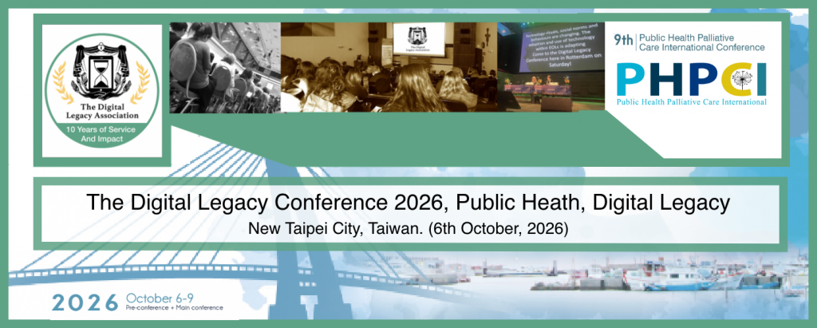

The Digital Legacy Conference 2026, part of Public Health Palliative Care International 2026

Press Release 7th September 2026
The Digital Legacy Conference 2026 (DLC 2026) will focus on Digital Legacy and its increasing importance within Public Health.
The DLC 2026 will take place as part of the Public Health Palliative Care International Conference 2026 (PHPCI 2026) in Taipei City on the 6th October 2026.
"This year's Digital Legacy Conference will be delivered in a supportive, academy format. It draws upon 10 years of experience and perfectly aligns with much of our work and campaigning. Our public health interventions to date include the development open access resources, societal empowerment, training, policies for governmental and non-governmental organisations and the delivery of technology interventions by mainstream social networks and care providers."
- James Norris, Founder of the Digital Legacy Association.

Programme theme
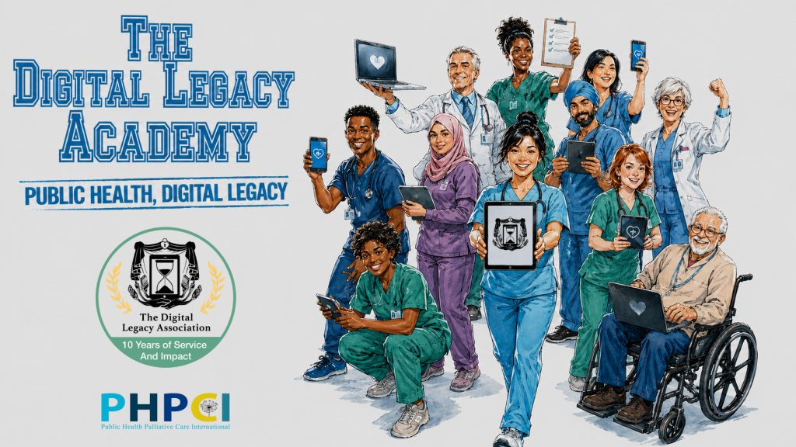
This year's theme is: The Digital Legacy Academy ‘Public Health, Digital Legacy. The academy format will be part conference, part workshop. This year’s objective is for each attendee to develop their own public health, digital legacy campaign. The Digital Legacy Association will support each attendee for six months following the conference. This format breaks away from the Digital Legacy Conference’s traditional, theatre based format.

Programme overview
The day will start by introducing the field of digital assets and digital legacy. This will take place through the lens of the general public and palliative care professionals. Examples of professionally led, public health, digital legacy interventions will be explored, analysed and celebrated.
Those attending will then reflect and document wishes for their own digital lives using the ‘Digital & Social Media Will Booklet’. Support will be provided to attendees with this task. The booklet will be provided to all attendees in a print format for free. This exercise will act as a springboard and provide a basic level of ‘lived experience’ in the context of planning for one’s digital life.
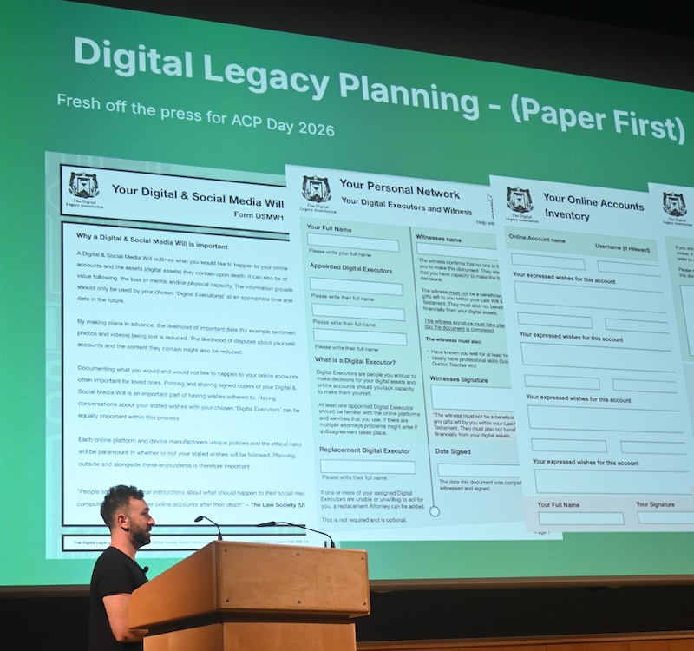
Roleplay and targeted discussions will follow. The day will conclude with an open discussion focusing on ‘overcoming barriers’. Barriers addressed will include mental, financial, time, culture, resource, knowledge, procedural, policy, safeguarding etc.
Attendees will leave with the confidence required to start having digital legacy conversations within their own professional practice. This includes both advance care planning and bereavement conversations.
Those attending will have the knowledge, desire and support to develop their own public health, digital legacy campaigns culturally suitable for the patients and communities they serve.

Part of Public Health Palliative Care Conference 2026
The Digital Legacy Conference 2026 will take place between 9am-12pm on the 6th October. It is included as part of Public Health Palliative Care International 2026 in New Taipei City, Taiwan.

About the Digital Legacy Conference (DLC)

The Digital Legacy Conference (DLC) is an annual, not for profit conference. It explores and celebrates the positive impact technology can have within the end of life planning, care and bereavement. The theme, goals and purpose is adapted each year based on the country and audience it is delivered to.

The DLC’s goal is to empower professionals with this increasingly important field. Through awareness, discussions and the sharing of knowledge, professionals are able to adapt their own practice and policies in order to better serve patients, families and communities.

The conference is organised by the Digital Legacy Association. Previous conference partners include Public Health Palliative Care International (PHPCI), The European Association of Palliative Care (EAPC), University College London Partners (UCLP), Siena University, Harlington Hospice and St Joseph's Hospice. The University of Birmingham will be the DLC’s partner in 2027.

About Public Health Palliative Care International (PHPCI)

PHPCI views death, dying, loss, and care as everyone’s responsibility, at least for those with the capacity to participate. A public health approach to end-of-life care sees the community as an equal partner in the long and complex task of providing high-quality care at the end of life.

The 9th International Conference on Public Health and Palliative Care presents a major opportunity to engage with Asia and support initiatives in Taiwan and beyond. This conference will promote the philosophy, values, concepts, and methods of Compassionate Communities, and help equip people with the educational and practical resources they need to advance the goals of health-promoting palliative care. PHPCI 2026 speakers include Dr. Kerrie Noonan, Professor Julian Abel, Professor Luc Deliens and Professor Samar Aoun.

Key Details

Date: 6th October 2026
Time: 9am-12pm
Ticket price: Digital Legacy Conference $40 USD. PHPCI ticket prices varies (Ticket link)
Location: Fullon Hotel Tamsui Fisherman’s wharf, New Taipei City, Taiwan

